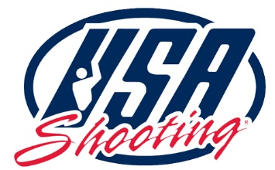
Directions
USA Shooting International Shooting Park
Olympic Trap and Skeet Shotgun Ranges
Fort Carson, Colorado

- Google Mapps – If you search for “USA Shooting Olympic Shotgun Range – Fort Carson” You will find the range location. You will enter off Colorado Hwy 115 at Fort Carson Gate 7, mile marker 37.

- Driving Instructions –

  - From US I-25 take the South Academy Blvd Exit 135. Head west on South Academy Blvd, toward the mountains. Once on South Academy move to the left lane.

  - You will drive approximately 2 miles on South Academy; exit left on South Hwy CO 115.

  - You do not need to stop at Fort Carson Gate 1 unless you did not obtain your access pass online. Gate 1 is located about 1 mile from South Academy Boulevard on Nelson Boulevard, where the Fort Carson Visitor Center is located. Stop here only if you have not received an online access pass. This applies to visitors without a REAL ID, U.S. passport, or foreign nationals.

  - If you have already received your access pass continue down CO Hwy 115 south to mile marker 37. Fort Carson Gate 7 is located at mile marker 37 on the east side of the CO Hwy 115, approximately 7 miles from South Academy blvd. On the west side of the highway, you will see the Sunview RV park.

  - Once you turn on the gravel road at Fort Carson Gate 7 you will need to wait for a USA Shooting representative to escort you to the shotgun range.

