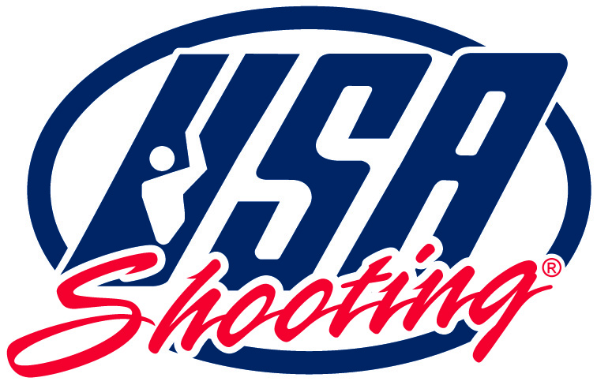
2026
USA Shooting Shotgun Fall Selections
Match Program
Shotgun Athletes,
USA Shooting is pleased to officially announce the 2026 Shotgun Fall Selection Match that will be held in Colorado Springs, Colorado, at the USA Shooting Shotgun Range at Fort Carson, August 28-September 7, 2026.
Please read this Match Program in its entirety! There is a great deal of material covered, and it is your responsibility to know the information referenced and contained within this Program when registering for, and attending, the competition.
We hope to see you at the match.
Ashley MacAllister, Match Director

2026 USA Shooting Shotgun Fall Selections

Match Dates
Colorado Springs, CO
Aug 28- Sept 1, 2026 -Skeet
Sept 3-7, 2026 -Trap

Locations
USA Shooting Olympic Shotgun Range
Fort Carson
Directions to the Fort Carson Shotgun Range can be found on the events page of the USA Shooting website.
https://usashooting.org/get-involved/events/

Match Director
Ashley MacAllister; ashley.macallister@usashooting.org

Eligibility
All Athletes must be a current Member of USA Shooting. If you are not currently a member, use this link to register or renew: link will be posted when the migration to Sport80 platform is completed
Junior Athletes are classified as those who are 21 and under before Dec 31, 2026.

Registration & Fees
$325 per event
Athletes competing in both events must register separately for each event.
USA Shooting is currently transitioning to a new event registration platform. Registration for this event will not open until July 2026. Registration information and links will be posted on the USA Shooting Events page and distributed through official USA Shooting communication channels once the new platform is operational.
Individual and Coach registration links will be published at that time.
Late entries are subject to approval by the Match Director and may include a late entry fee.

Cancellation Policy
Cancellations prior to August 21, 2026 will receive a full refund of match fees, minus a small administrative fee.
Cancellations after August 21, 2026 will not be refunded, except for emergencies or illness.

SafeSport & Background Screening
SafeSport Training and Background Screening is required for Coaches over the age of 18 is required.
SafeSport training can be found through your membership profile at https://members.usashooting.org/member/login, in the "Membership Information" section. SafeSport Training can be started through the "SafeSport Training" tab on the left-hand column of your profile.
All Coaches, Athletes, and Guardians should familiarize themselves with the following policies:
Minor Athlete Abuse Prevention Policies (MAAPPs)
https://uscenterforsafesport.org/training-and-education/minor-athlete-abuse-prevention-policies/ and
https://usashooting.org/resource-center/#category-safesport
Reporting Policy for all alleged sexual, emotional abuse, physical abuse, and violations of the MAAPP
USA Shooting Reporting Policy and USA Shooting Quality Control Policy.

Check-In
ATHLETES
All athletes must complete event check-in prior to the start of Match Day 1.
Check in will open at noon the day before PET. You can check in for the event at the Clubhouse.
COACHES
All coaches must check in with USA Shooting upon arrival.
To receive a coaching wristband for the competition, coaches must have current SafeSport Training and a valid USA Shooting Background Screening on file prior to the event.
Coaches who do not have current SafeSport certification and an approved background screening on file with USA Shooting will not be eligible to receive a coaching wristband or access athlete competition areas.
Schedule
Colorado Springs - Please see detailed schedule
Date | Day | Details
August 28, 2026 | Friday | Check-In & PET Skeet (Pre-Event Training)
August 29, 2026 | Saturday | Skeet Match 75 targets
August 30, 2026 | Sunday | Skeet Match 50 targets, (Finals International and Sr categories)
August 31, 2026 | Monday | Skeet Match75 targets
September 1, 2026 | Tuesday | Skeet Match50 targets, Open & Junior Match Finals & Awards
September 3, 2026 | Thursday | Check-In & PET Trap (Pre-Event Training)
September 4, 2026 | Friday | Trap Match 75 targets
September 5, 2026 | Saturday | Trap Match 50 targets, (Finals International and Sr categories)
September 6, 2026 | Sunday | Trap Match 75 targets
September 7, 2026 | Monday | Trap Match 50 targets, Open & Junior Match Finals & Awards

Start Lists
It is the Athlete’s responsibility to check the Start Lists for their events and know when and where they are scheduled to compete. Start Lists will be posted at the range, and online on the USAS website Events page. Relay and Firing Point assignments for PET and Match Day 1 will be the same. Start lists will be released the afternoon before the event for the next day, please be aware that Start Lists are subject to change, so double-check your assignment on the day of the match!

Course(s) of Fire

Qualification
Athletes will fire two (2) ISSF qualification courses of fire during the 2026 USA Shooting Shotgun Fall Selections Match.
For selection purposes, qualification scores fired at the 2026 USA Shooting National Championships and the 2026 USA Shooting Shotgun Fall Selections Match will be combined to create a four (4) match aggregate qualification score.

Finals Qualification
The top eight (8) eligible athletes in each event will qualify for the Final based upon the aggregate of:
- Two (2) qualification scores fired at the 2026 USA Shooting National Championships; and
- Two (2) qualification scores fired at the 2026 USA Shooting Shotgun Fall Selections Match.

Finals Format
Open Finals will be conducted using the current ISSF Elimination Finals format and the 2026 Selection Procedures.
Open Finals points will be awarded to the 1st-3rd place athletes. 1st place will receive 3 points, 2nd place will receive 2 points and 3rd place will receive 1 point added to their aggregate score for team selection.
The Selection Final will determine Open Category award placement and will be used in calculating final team selection rankings in accordance with the 2026 USA Shooting Shotgun Selection Procedures.
Final rankings used for team selection will be determined by the combined total of:
- Two (2) qualification scores from the 2026 USA Shooting National Championships;
- Two (2) qualification scores from the 2026 USA Shooting Shotgun Fall Selections Match; and
- Finals points from One (1) Final from the 2026 USA Shooting Shotgun Fall Selections Match.

All other finals will be conducted using the current ISSF Elimination Finals and utilize the qualification score from the current match to select finalists.

Award Categories

Open Category Awards
Open Category awards will be determined by the final standings at the conclusion of the Fall Selection Final.

Junior Category Awards
Junior Awards will be determined based off of the Junior Final placements.

Rules
USA Shooting Rules, ISSF Rules, Match Director Bulletins, and the 2026 USA Shooting Shotgun Selection Procedures will govern this competition. All competitors are responsible for knowing and complying with these rules and procedures.
Links to the ISSF Rulebook are available below:
https://backoffice.issf-sports.org/getfile.aspx?mod=docf&pane=1&inst=455&file=ISSF-Rule-Book-2026-Edition-2025-First-Print-12-2025-Effective-1-January-2026.pdf

Equipment
Equipment legality consultation will be available before each event. Please ask a Range Official if you have questions regarding equipment compliance.

Clothing
Kaki, Jean, and Green clothing will be allowed at this competition. No religious, or political propaganda will be allowed.

Team Selection
Team selection rankings for all three competitions will be determined in accordance with the 2026 USA Shooting Rifle Selection Procedures.
Only the Top Eight (8) Finalists in each event will be eligible for nomination to these teams.
- The qualification scores fired during the 2026 USA Shooting Shotgun Fall Selections Match will carry forward into the next National Team selection match and will be combined with the next selection match scores.
Junior National Team Selection: this competition is the first stage in selecting the 2027 Junior National Team.

Protests
A fee of $50.00 will be charged for protests. An official Protest Form must accompany any protest. Protest forms are available on ISSF Website.

Officiating
Juries will be appointed and convened as required to resolve any protest. The jury will resolve any scoring challenges. Decisions of the jury are final.

Travel
Competitors are responsible for making their own travel and hotel arrangements. Nearby airports are Colorado Springs (COS), and Denver (DEN).

Volunteers
Volunteers are a HUGE part of our success. Please take the time to thank our Range Officials - we truly could not host this event without them. If you are interested in helping with this match or others, please contact Ashley MacAllister for details on how to get involved.

Subject To Change
Please keep in mind that the Match Schedule and Start Lists are subject to change. Although we make every attempt to maintain the published schedule, maintenance issues and other items are out of our control. It is the responsibility of Athletes and/or Coaches to check the Schedule and Start Lists daily. Updated information will be communicated to registered competitors’ emails.
USA Shooting is not responsible for missed flights, airline change fees, missed relays, etc. Please keep this in mind when making your travel arrangements and schedules.

Contact Information
If you have any questions, please email ashley.macallister@usashooting.org

Military Installation Access & Arrival Information
All athletes, coaches, officials, and spectators must obtain Fort Carson installation access before arriving.
Event Access: https://pass.aie.army.mil/?b=usa&i=carson&e=VTV3ZMQP
Visitors with a REAL ID or U.S. Passport may register online. Military ID holders do not require a pass. International visitors and visitors without a REAL ID must report to Gate 1 Visitor Center before entering Gate 7.
Practice begins August 21, 2026, daily 9:00 AM–4:00 PM. Gate 7 opens at 9:00 AM. Assistance: Brent McPherson (719)651-3108; Dwayne Weger (214)505-3379; Mike Axelrod (808)225-8266.

