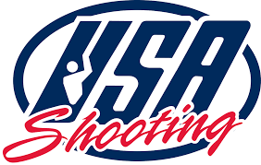

**USA Shooting 2024 Olympic Trials**

**Match Director’s Bulletin #1 – Coach Wristbands**

**September 28, 2023**

**In accordance with Safe Sport compliance, all Coaches must have a colored wristband to interact with Athletes or Range Officials on the Field of Play.**

**Registered Coaches who are permitted to coach Athletes who are not their own child based on Safe Sport and USOPC background screening completion will receive one color wristband.**

**Wristbands are available at Match Check-In, or from the Match Director, contingent on Safe Sport and background screening completion status.**

**Ashley MacAllister**

**Match Director**

**USA Shooting 2024 Olympic Trials**

**Match Director’s Bulletin #2 – Clothing**

**September 28, 2023**

**For this competition, we will not be enforcing the rule on attire banning jeans and camouflage clothing on the firing line or in the general range areas under ISSF Rule 6.20.3.1. There will be no punishment for this attire being worn. The remaining portions of this rule concerning shorts length, clothing with holes, clothing with vulgar or inappropriate messages, etc. will be enforced at the discretion of the Match Director.**

**Ashley MacAllister**

**Match Director**

**USA Shooting 2024 Olympic Trials**

**Match Director’s Bulletin #3 – Frame Hits on Electronic Targets During Match Firing**

**September 28, 2023**

**During this Match, any competitor who hits the frame of the electronic target two or more times will be asked to stop shooting and is required to withdraw from the Match for the remainder of the day. The competitor’s score up to that point will be recorded and counted, but all remaining series for that day after the second frame hit will be recorded as “DNF.”**

**Ashley MacAllister**

**Match Director**